DOCUMENTATION
*Abstract*
The Vehicle Parking Management System is a software application designed to manage and monitor the parking of vehicles in a parking lot. The system allows users to park and remove vehicles, displays the availability of parking slots, and provides information about parked vehicles. This project aims to provide an efficient and organized way of managing vehicle parking.

*Introduction*
Vehicle parking management is a critical aspect of facilities management in shopping malls, offices, and other public places. Manual parking management systems can be time-consuming and prone to errors. The Vehicle Parking Management System is designed to automate the parking process, making it more efficient and convenient for users.

*Software Requirements*
- Operating System: Windows or Linux
- Programming Language: C
- Compiler: GCC
- Development Environment: Any text editor or IDE

*Hardware Requirements*
- Processor: Any processor with a C compiler
- RAM: 256 MB or more
- Storage: 10 MB or more

*Code*
#include <stdio.h>
#include <stdlib.h>
#include <string.h>

#define MAX_SLOTS 10

Typedef struct Vehicle {
Char licenseNumber[20];
Char ownerName[50];
Char vehicleType[20];
Int slotNumber;
} Vehicle;

Vehicle parkingSlots[MAX_SLOTS];
Int occupiedSlots = 0;

Void displayMenu() {
Printf(“Vehicle Parking Management System\n”);
Printf(“1. Park a vehicle\n”);
Printf(“2. Remove a vehicle\n”);
Printf(“3. Display parked vehicles\n”);
Printf(“4. Check availability\n”);
Printf(“5. Exit\n”);
}

Void parkVehicle() {
If (occupiedSlots < MAX_SLOTS) {
Vehicle vehicle;
Printf(“Enter license number: “);
Scanf(“%s”, vehicle.licenseNumber);
Printf(“Enter owner name: “);
Scanf(“%s”, vehicle.ownerName);
Printf(“Enter vehicle type: “);
Scanf(“%s”, vehicle.vehicleType);
Vehicle.slotNumber = occupiedSlots + 1;
parkingSlots[occupiedSlots] = vehicle;
occupiedSlots++;
printf(“Vehicle parked successfully at slot %d\n”, vehicle.slotNumber);
} else {
Printf(“Parking lot is full\n”);
}
}

Void removeVehicle() {
Int slotNumber;
Printf(“Enter slot number: “);
Scanf(“%d”, &slotNumber);
If (slotNumber > 0 && slotNumber <= occupiedSlots) {
For (int I = slotNumber – 1; I < occupiedSlots – 1; i++) {
parkingSlots[i] = parkingSlots[I + 1];
}
occupiedSlots--;
printf(“Vehicle removed successfully\n”);
} else {
Printf(“Invalid slot number\n”);
}
}

Void displayParkedVehicles() {
If (occupiedSlots > 0) {
Printf(“Parked Vehicles:\n”);
For (int I = 0; I < occupiedSlots; i++) {
Printf(“Slot Number: %d\n”, parkingSlots[i].slotNumber);
Printf(“License Number: %s\n”, parkingSlots[i].licenseNumber);
Printf(“Owner Name: %s\n”, parkingSlots[i].ownerName);
Printf(“Vehicle Type: %s\n\n”, parkingSlots[i].vehicleType);
}
} else {
Printf(“No vehicles parked\n”);
}
}

Void checkAvailability() {
Printf(“Available slots: %d\n”, MAX_SLOTS – occupiedSlots);
}

Int main() {
Int choice;
While (1) {
displayMenu();
printf(“Enter your choice: “);
scanf(“%d”, &choice);
switch (choice) {
case 1:
parkVehicle();
break;
case 2:
removeVehicle();
break;
case 3:
displayParkedVehicles();
break;
case 4:
checkAvailability();
break;
case 5:
exit(0);
default:
printf(“Invalid choice\n”);
}
}
Return 0;
}

*Result*
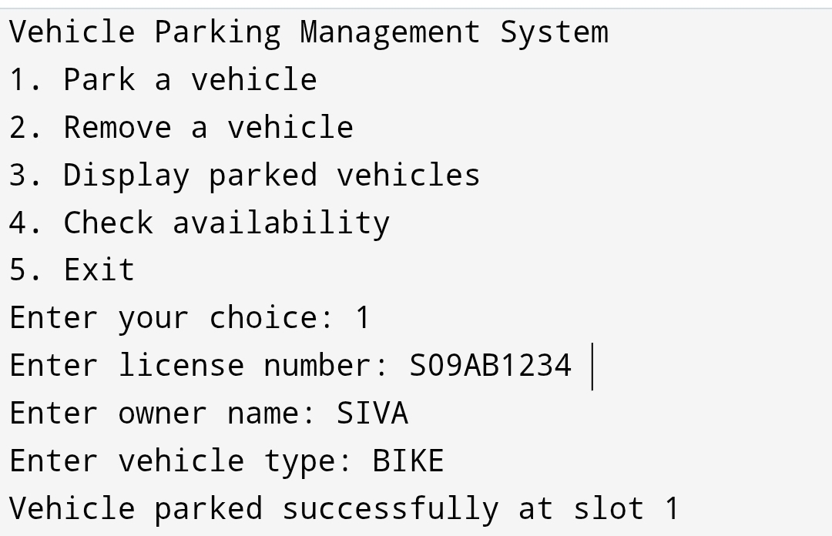

*Conclusion*

The Vehicle Parking Management System is an efficient and organized way of managing vehicle parking. The system provides a user-friendly interface and automates the parking process, reducing errors and saving time. The system can be further improved by adding more features, such as payment processing and vehicle tracking

